**INSURANCE MANAGEMENT PROJECT USING TKINTER AND MYSQL**

A project Report

Submitted in the partial fulfilment of the requirements for the award of the Degree

**BACHELOR OF SCIENCE (COMPUTER SCIENCE)**

**BY**

Ellison Povo – 55

Harsh Helaiya – 51

**UNDER THE ESTEEMED GUIDANCE OF**

**Mr. Hasan Phudinawala**



**DEPARTMENT OF COMPUTER SCIENCE**

**NAGINDAS KHANDWALA COLLEGE**

***(Affiliated to University of Mumbai)***

**MUMBAI – 400 064**

**MAHARASHTRA**

**2020**

Contents

Introduction 2

Purpose and scope 2

Purpose 2

Scope 2

Objective 2

Hardware and Software requirement 3

Software Requirement 3

Hardware Requirement 3

Code screenshots 4

Outputs and discussion 9

Login Page 9

Homepage 9

Policy Registration 10

Vehicle Registration Page 10

Car Registration Page 11

Bike Registration Page 11

Conclusion and future scope 12

Conclusion 12

Future scope 12

INSURANCE MANAGEMENT

# Introduction

Our project topic is Insurance management using python module tkinter. It is GUI(Graphical user interface) based project. This we make for user easily manage the insurance. Insurance Policy data management system is which is developed for tracking the details of the insurance policy, customer details and company details. This series of insurance analysis and information management system that provides easy access of information regarding the people and resources of insurance. User can view their own personal details when login into the Profile module. This project is useful for any kind of insurance company to manage the insurance details, to sanction the insurance for customer, process the insurance policy details and all kind of insurance process through online. The Insurance management system is a complete solution for organizations, which need to manage insurance for their vehicles, equipment, buildings, and other resources. This insurance management system can efficiently manage the company, records, provides instant access and one that improves the productivity. It will show details about insurance and its types, also it will show the details about different duration schemes to the corresponding insurance type or insurance policy. The main objective of the developed system is to allow admin users to register insured persons with their name, date of birth, residence address, medical history and also policy details

# Purpose and scope

## Purpose

The purpose of this project is to create a GUI based software which is easier for the end user to understand and lodge in the details into the software. The end user with the minimum technical knowledge could easily use the graphical interface as most of the software is self-explanatory. The software’s main highlight is that the end user can easily lookup the customer details in the get customer info tab without being connected or having access to the database. The ultimate purpose of the software is user friendliness in correspondence with proper functionality

## Scope

Scope Our project is like any other project of Insurance Management system using tkinter module of python programming language. The project is intended to make policy registration of the customer details easier and less effort. This type of software can be implemented by a Insurance organization or a small Insurance company which provides basic Insurance services. This type of software has very low maintenance and can be executed in the most basic system. The net booting time of this GUI based software is in milliseconds which makes it faster for user to boot the program and get going

# Objective

This project of Insurance management is completely developed with the intention of easing the ability to perceive study and use the software. The ultimate objective of this project is to shift the focus of prominent command line interface (CLI) based software to a simple graphical user interface (GUI) which is easier for the people from a non-technical background to be easy to use. This program is intended to serve a purpose and solve the problems of the people who don’t want to invest much in the software, as it has very light weight software which executes without much load on the system. One of the main highlights of this project is that you do not require to be connected to the database to view the customer details and to alter the records of the customers, which gives the end user full confidence and freedom to use the software. This contains a home page which is intended for simpler user interaction. We have focused not only on the functionality but also tried making it more colorful and appealing which serves as an eye candy for the user, not to feel bored after extensive usage.

It contains:

1. Login page

2. Homepage

3. Health Insurance

4. Vehicle Insurance

5. Feedback form

6. About us

7. Exit

All these tabs or buttons makes it very easy to understand the software and use

# Hardware and Software requirement

## Software Requirement

An attractive Insurance Management System requires the amalgamation and utilization of modern technologies like the Python, tkinter module and MySQL.

Python – we can use any text editor but IDLE or the official python text editor is preferred as it tends to throw less errors and does not requires us to install any other packages.

Tkinter module – The tkinter module can be directly imported from the python library. It is the one which facilitates the creation of the GUI.

MySQL – This is the software in which the user can create databases and tables where the data can be stored for future reference and analysis.

## Hardware Requirement

The minimum hardware requirement is that the system on which the program is to be executed should be a computer comprising of an operating system such as windows or Linux or mac. The program cannot be executed over an android or an IOS device. The computer must consist at least an Intel i3 processor, 2gb RAM and 12-inch display. This is the minimal hardware requirement for the functionality of the program at its best performance

# Code screenshots

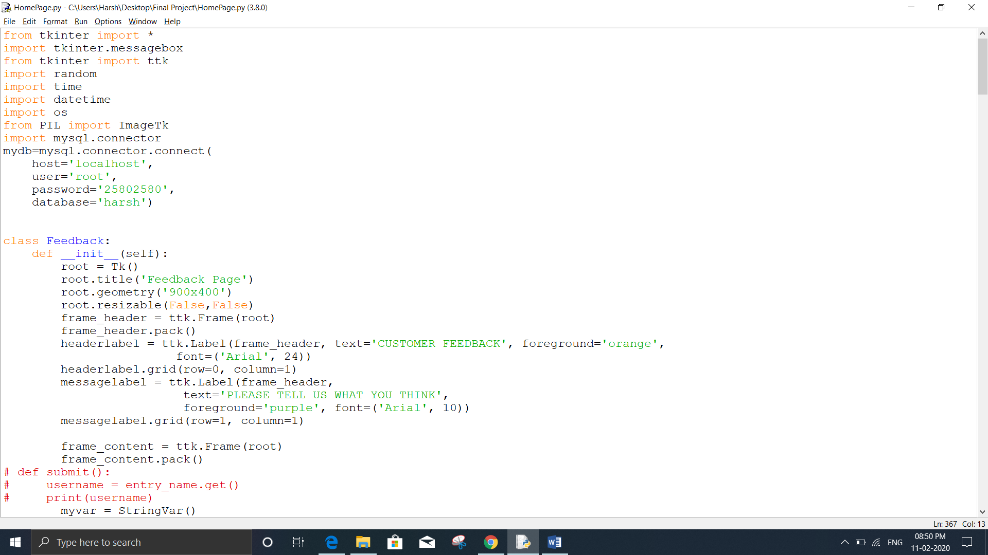

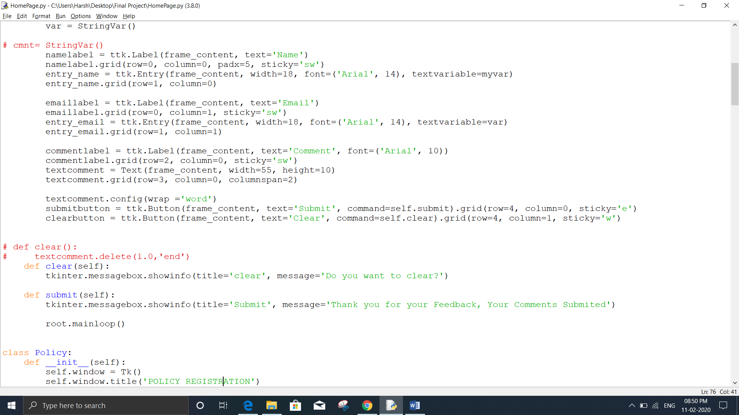

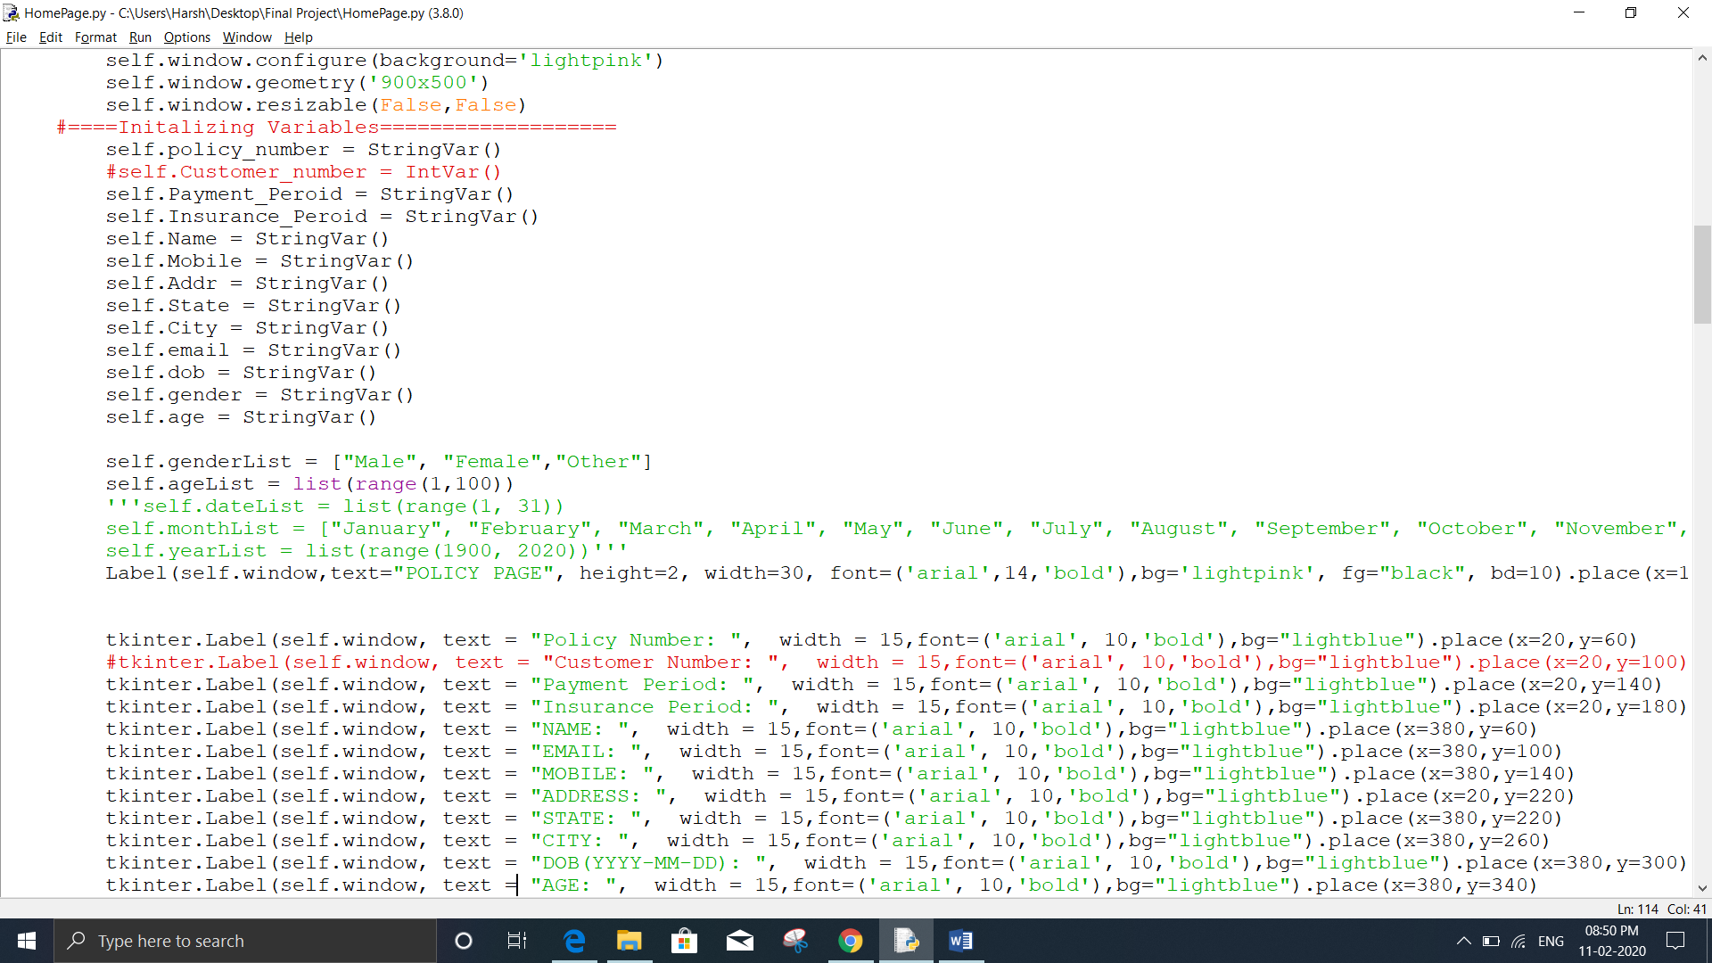

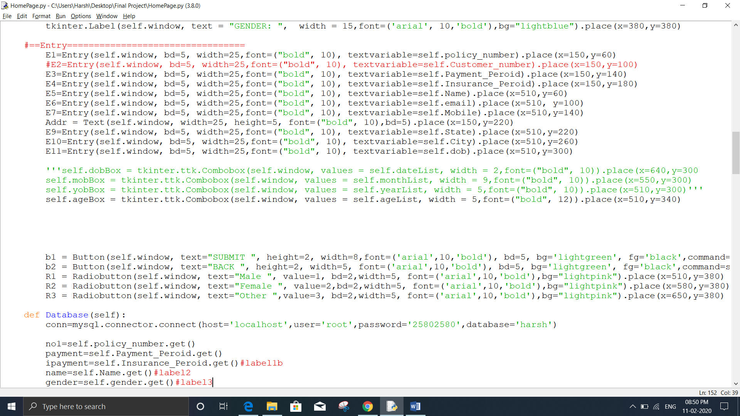

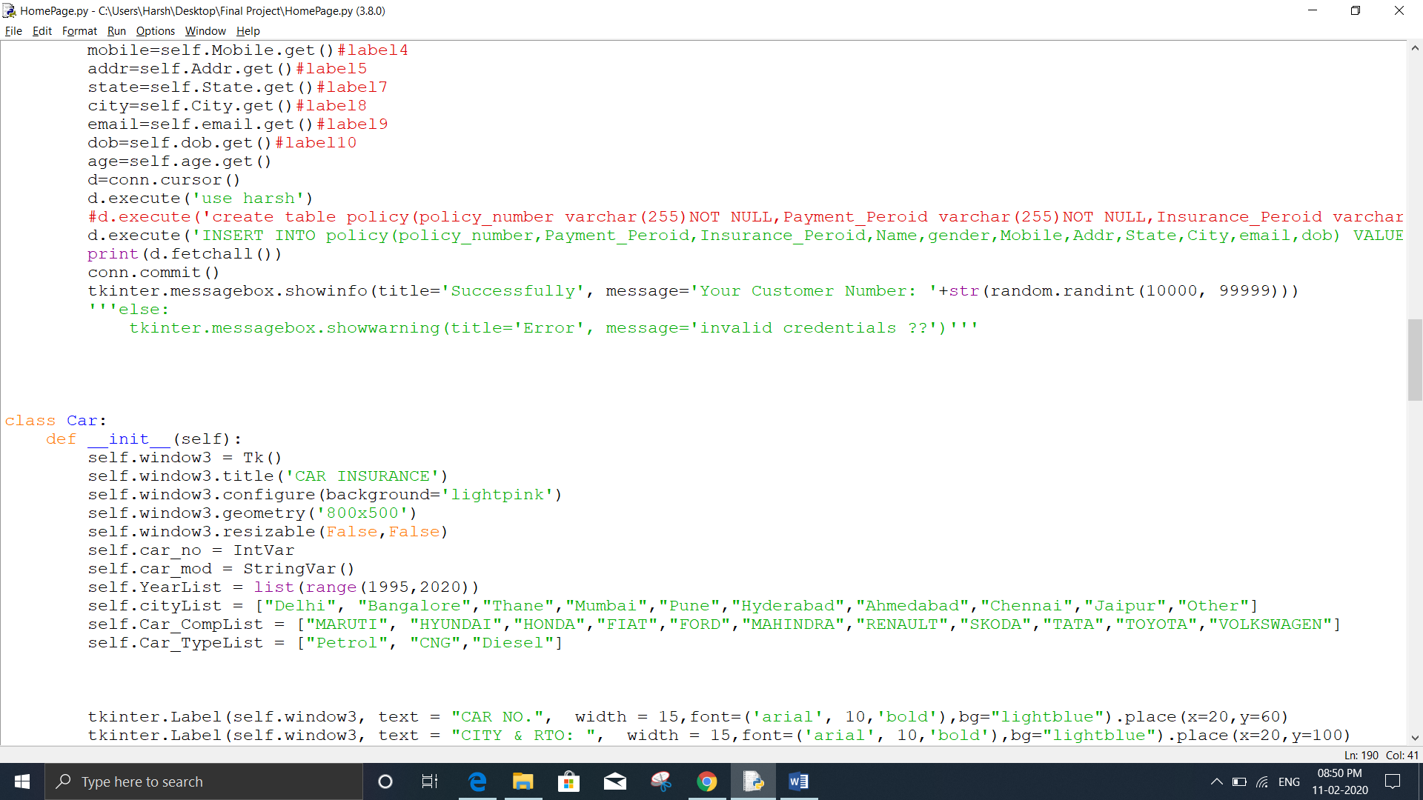

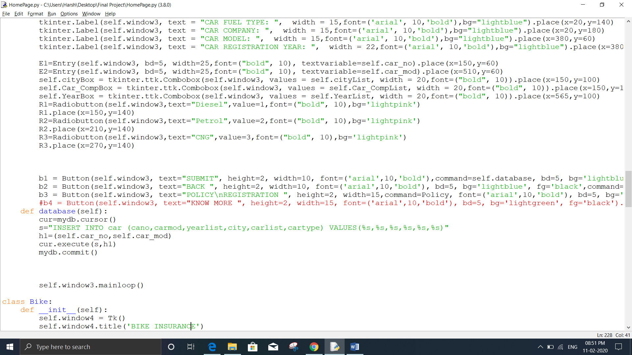

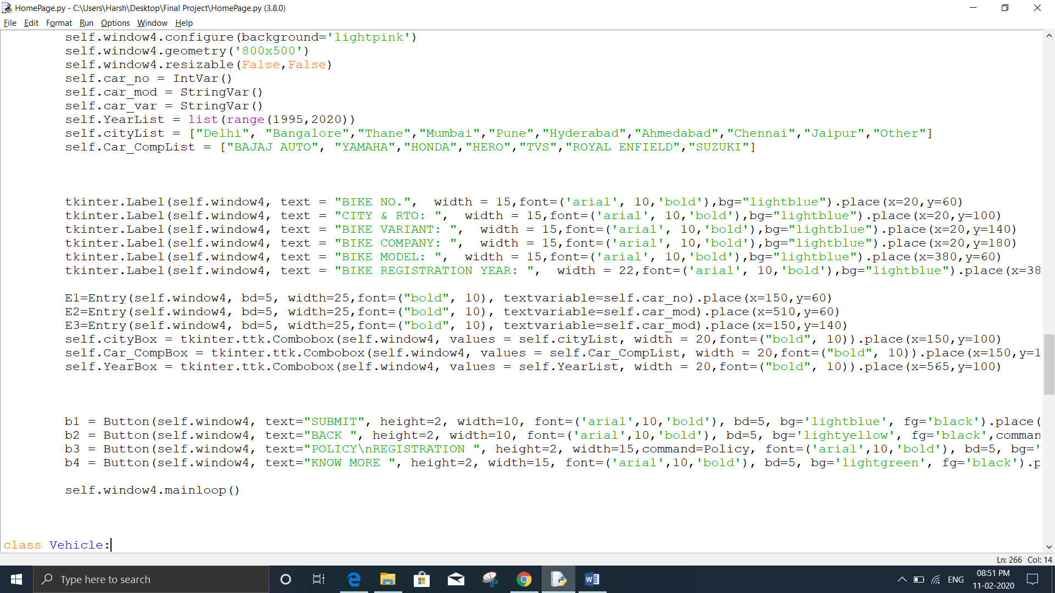

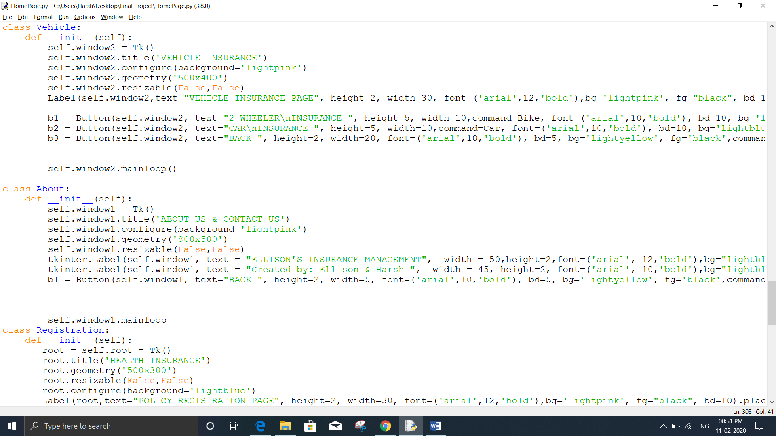

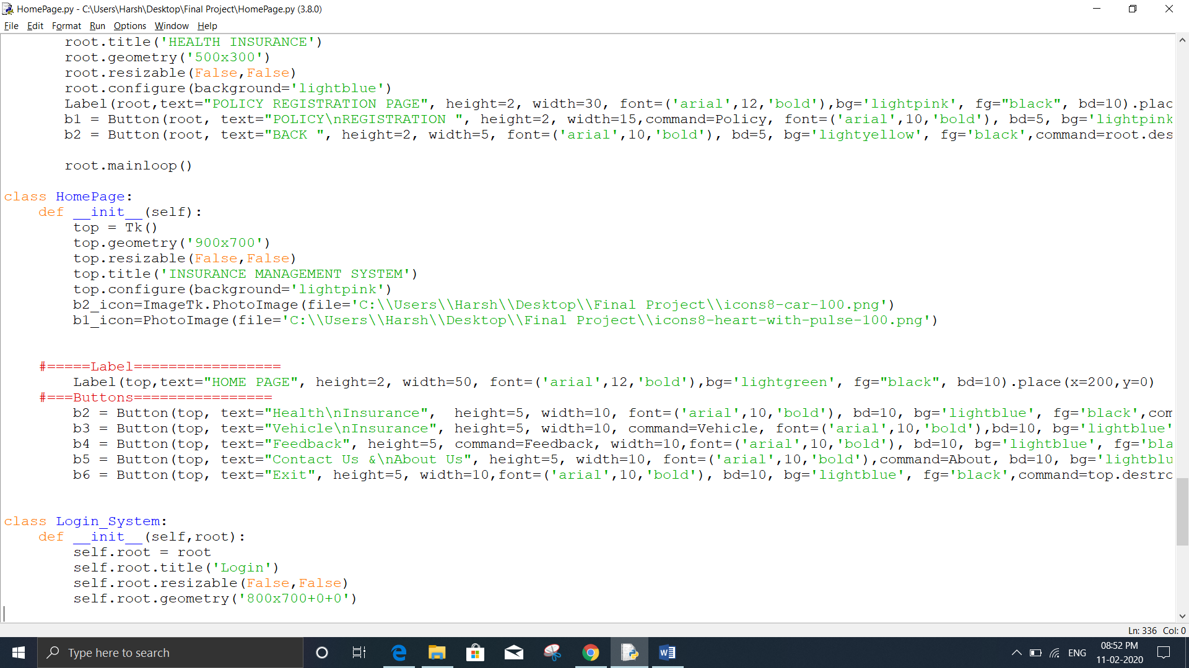

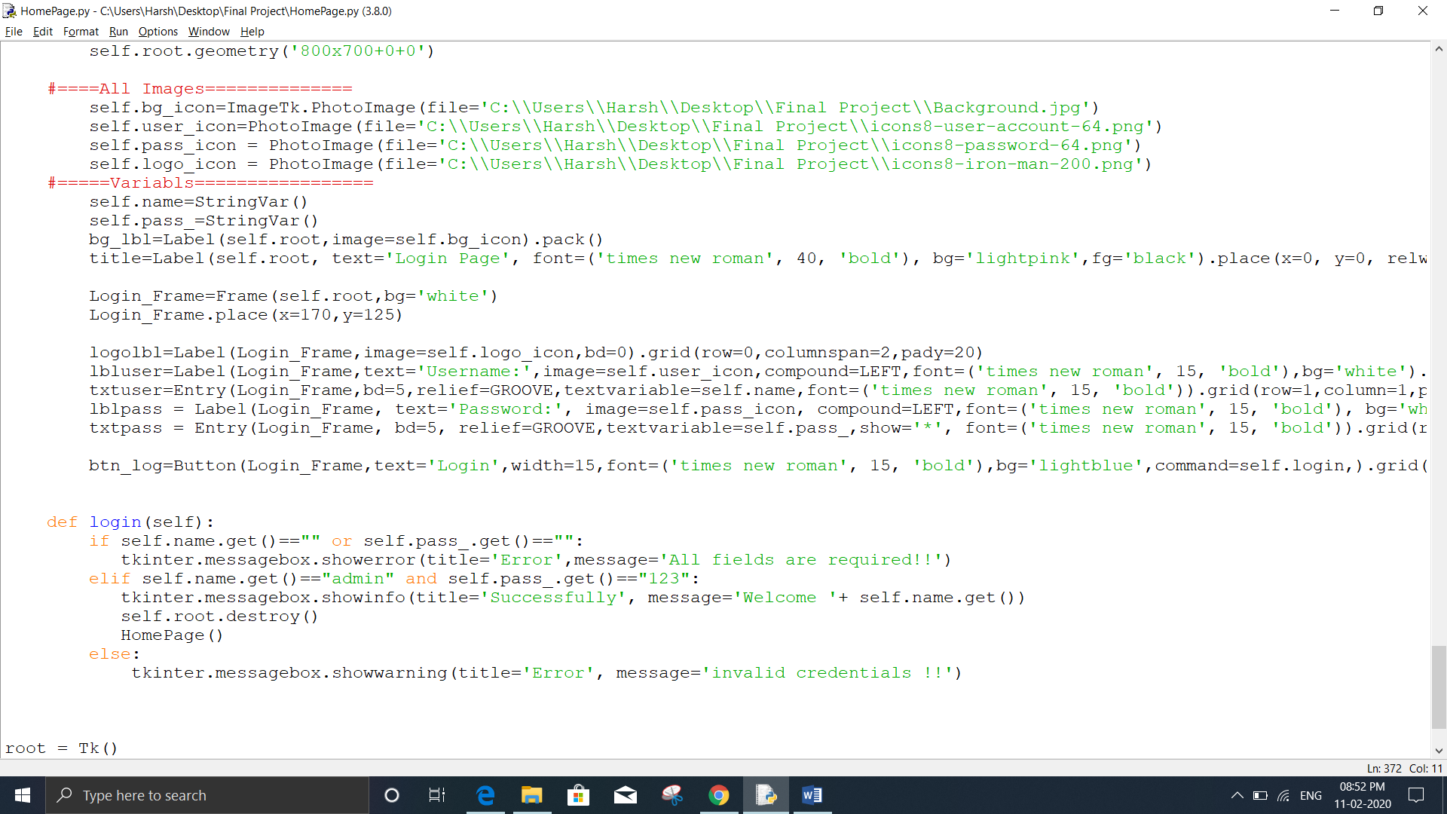

# Outputs and discussion

## Login Page

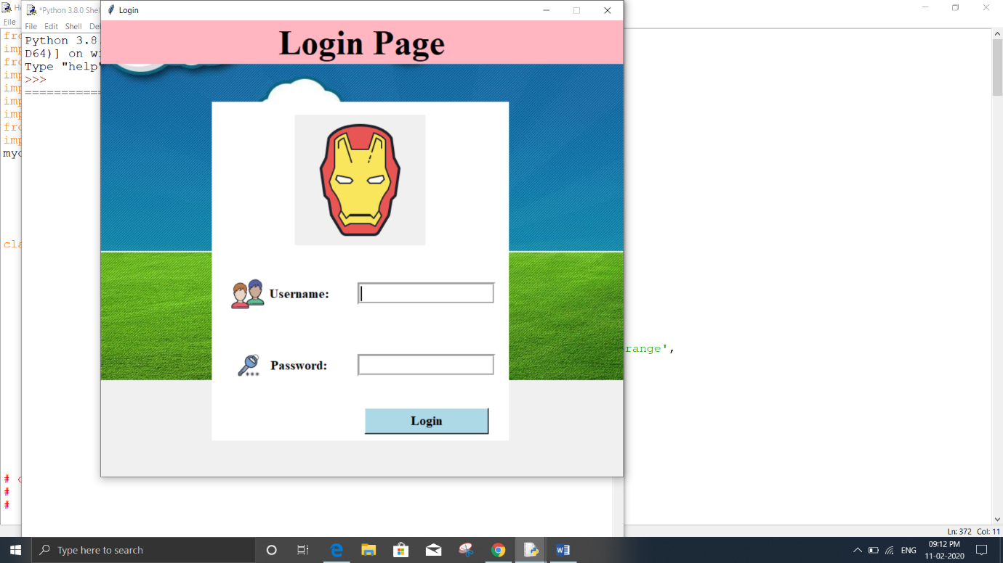

In this page we can login into our system.

## Homepage

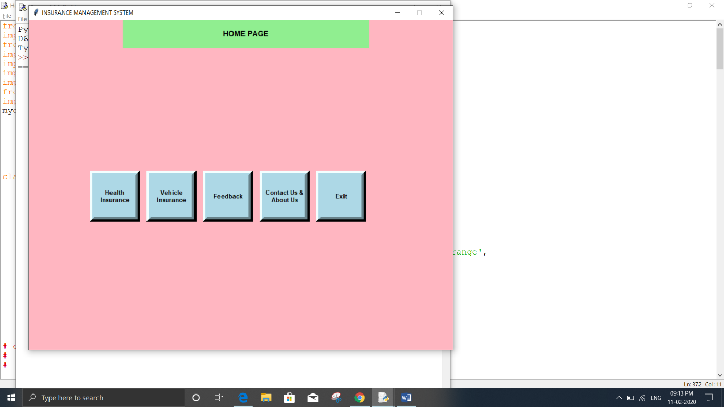

This is our home page or interface of software where we can access all the buttons. It contain Health insurance, vehicle insurance, feedback, and many more buttons.

## Policy Registration

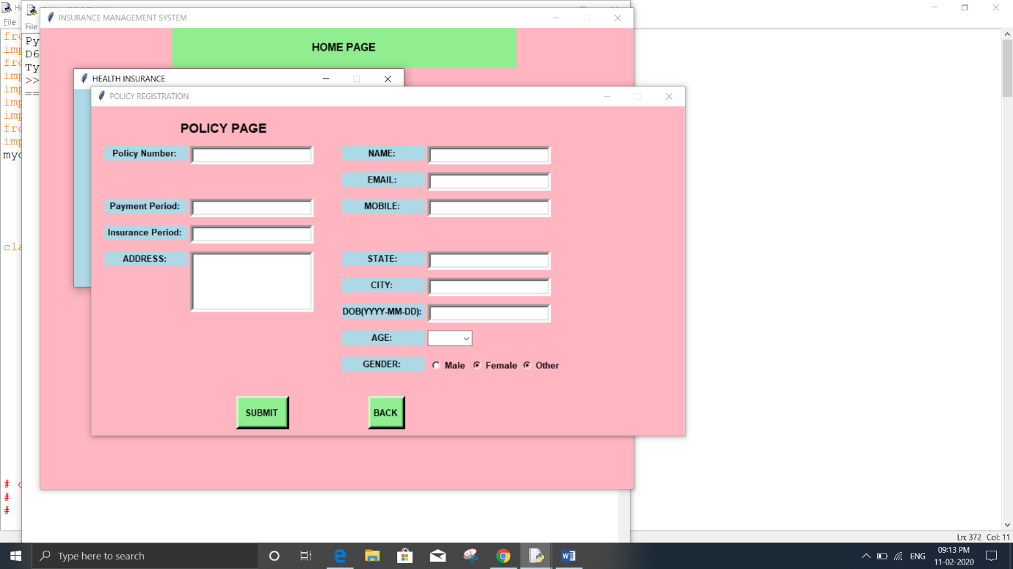

Here we can registrar our insurance policy.

## Vehicle Registration Page

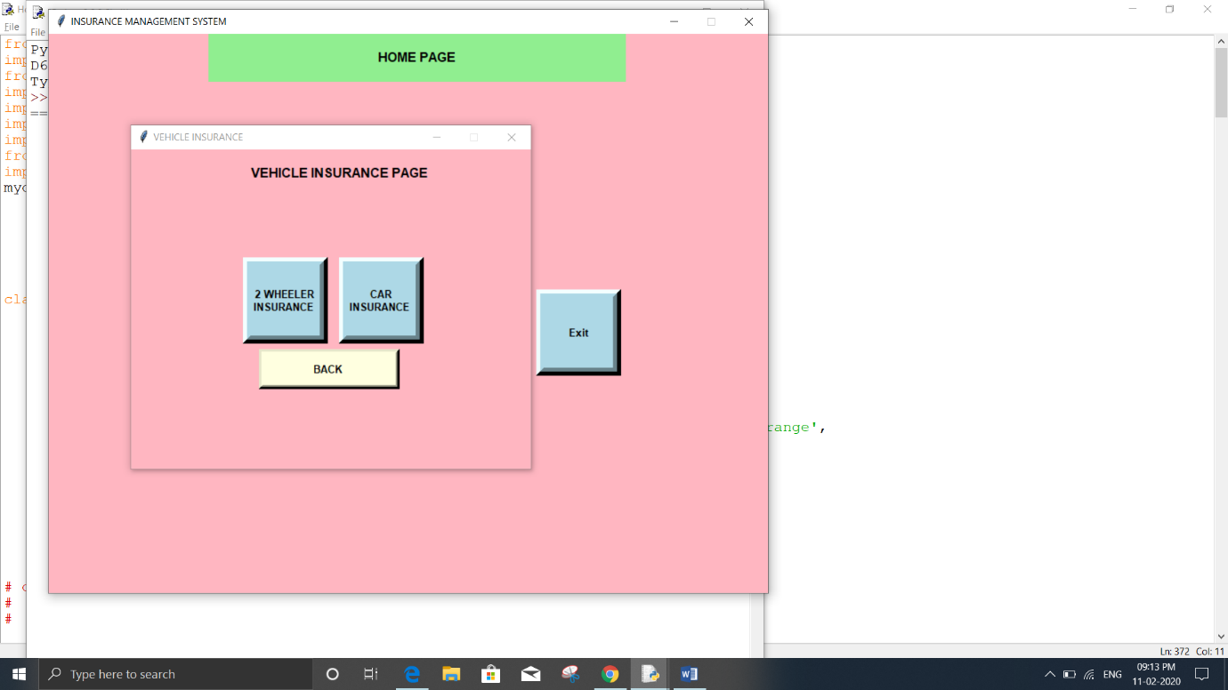

In this page we can take insurance of vehicle here it divide into two part bike insurance and car insurance. It shows below

### Car Registration Page

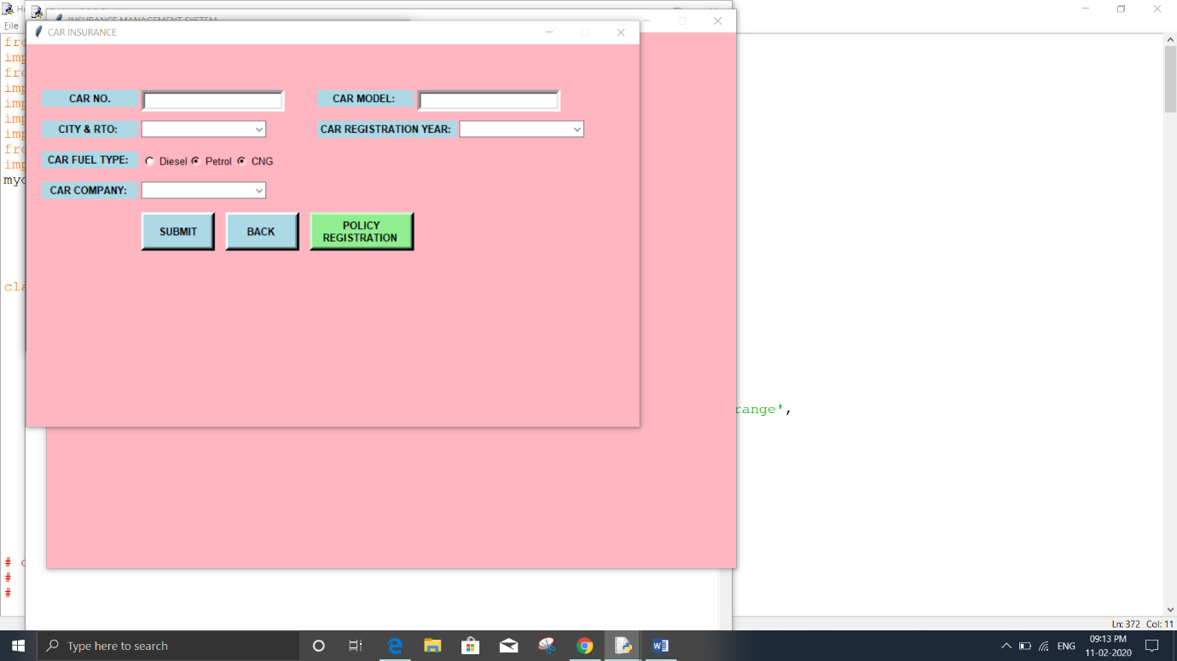

In this page we can take car insurance.

### Bike Registration Page

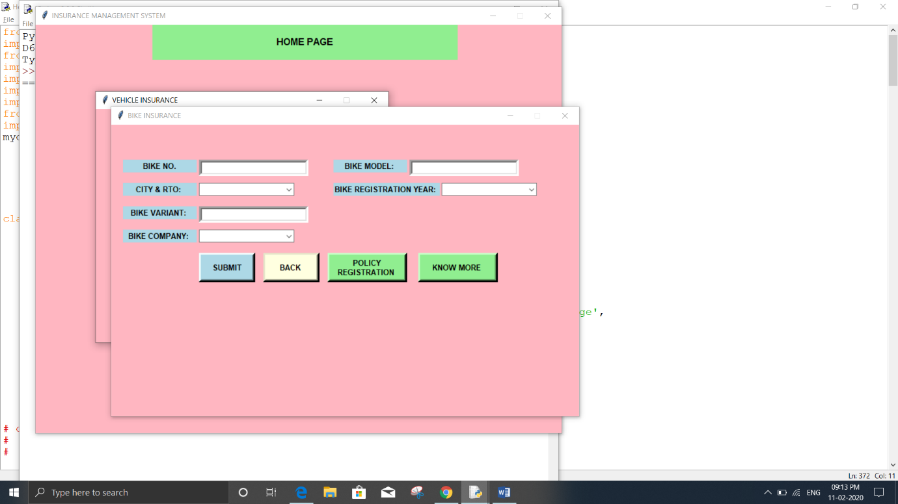

In this page we can take bike insurance.

# Conclusion and future scope

## Conclusion

This software is useable and very easy to use. This software is mainly for organization.

## Future scope

We will add more insurance service like personal insurance, term life insurance and many more. We can also add pages or software interface for management people or organization employee who can make or access to customer. That makes customer satisfy.